Objective Questions

- What is the total number of attributes in the customer table?
Answer:
The number of attributes terms to the number of columns, where the “customer table” contains the 3 attributes.
They are, CustomerID, Customer Age, Customer Gender.

- How will you get the “Customer’s” ages in the “Order” tables according to customer IDs?
Answer:
To get an Customer’s age column in orders table based on the Customer ID’s by,
Moving to Model View then dragging CustomerID from Orders table to CustomerID of Customers table making a relationship of the “one to many” (One Customer to Many Orders
Adding a new column named “Customer Age” in Orders table by using the DAX
Here this creates a column “Customer Age” in Orders table that looks up the matching age on the relationships.

- In analysing the dataset with Power BI, ensure data cleaning to address inconsistencies and missing values before further analysis.
Answer:
Loaded data to the Power Query Editor for the data transformation process for better reporting purpose,
- Analysed the column Reason with blank cells comparing with the status column, as status column with “Delivered” indicates reason “Not Applicable” by replacing Blank cells, while the status column with “Returned” and reason with blank cells indicate “No Return Reason” using the custom column formula.
- Removed the extra columns present in the dataset, named “column 18” to “column 22” that totals 5 columns
- Removed the rows by “Remove Blank Rows”, which removes the 199 rows.
- Particularly columns named “Unit Price” and “Quantity” are still showing 8 blank row values with corrupted data towards “Sale Price” column value showing the “shipping fees” column values, which even it’s not possible to reverse calculate for unit price and quantity column, so for better readability of data for dashboard making removed those 8 rows completely.

- How can we calculate the total revenue generated by all the sales?
Answer:
The Total Revenue by all Sales is 107.24 M.
Calculated Total Revenue by using the DAX function and added the new measure named “Total Revenue” using the SUM() function to Sale Price column present in the Orders table.
DAX formula:
Total Revenue = SUM(orders[Sale Price])
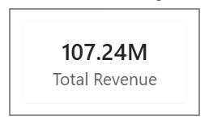

- What is the total number of unique customers who made purchases each year? Is there any increase in the number over the years?
Answer:
Here to find the number of unique customers purchased in each year is performed by considering the “Year” (Date Hierarchy) and the Count (Distinct) of the CustomerID from Orders table results the number of Unique users on Year basis.
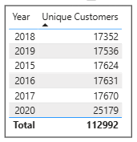
I placed the table visual by adding the “Year” and “Count (Distinct) of CustomerID” results the unique users accordingly on year basis.
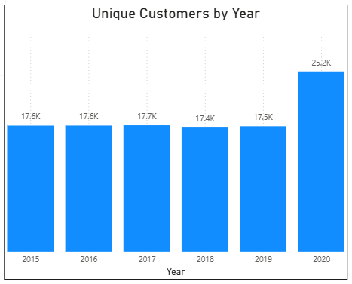
Similarly placed the Clustered Column Chart - visual by placing the “Year” of Order Date column on the X-axis and “Count (Distinct) of CustomerID” on the Y-axis along with enabling data label showing exact values.
Visuals from the Table and Chart we can observe that from year 2015 to year 2019 maintains under 17.5 K to 17.7 K, while from year 2019 to year 2020 we can see a huge spike from 17.5 K to 25.2 K showing the growth of 7.7K users in a year, by showing a growth rate by 42.5%.

- How can we determine the total number of unique products available in the company?
Answer:
The Total Unique Products in Company is 44
To find the Total number of the Unique products present in the Company by using the DAX measure formula:
Total No. of Unique Products = DISTINCTCOUNT(Orders[Product])
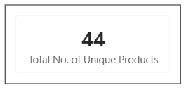
Here the DAX formula works by counting the distinct products present in the column named “Product” under table “Orders”. The DISITINCTCOUNT extract the each product name once which are present in entire column.
For visual using the card and added the new measure formed by the DAX formula.

- What is the average number of days it takes for products to be delivered, get the metric for only the delivered orders.
Answer:
The Average Number of Delivery Days is 9.41 which indicate between the 9 to 10.
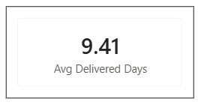
Calculated by difference between order date and delivery date resulting the new column named “Delivery Days”, then for average calculation used the DAX measure using the CALCULATE() function included the AVERAGE() and proper condition need to be considered.
For new column creation in orders table,
Delivery Days = DATEDIFF(Orders[OrderDate],Orders[Delivery Date],DAY)
DAX formula:
Avg Delivered Days = CALCULATE(
AVERAGE(Orders[Delivery Days]),
Orders[Status] = “Delivered”
)
The formula work in a way making the date difference of order date and delivered date by set the DAY value.
Then the CALCULATE function perform calculation of the AVERAGE of the delivered days by restricting status to only Delivered, results to Average number of days taken to product to get delivered.

- Which products, categories, and subcategories are the most popular?
Answer:
To get the most popular products, products category and sub category based on the number of sale count comes to be same around the 2565 to 2569, which causes difficult to identify the products and so on.
So to over come this I used the Total Revenue for the identification of most popular products, products category and sub category.
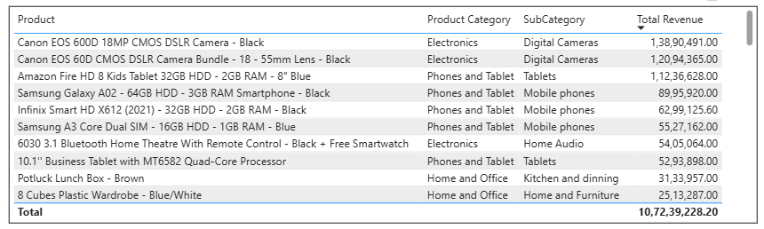
Here in the above table shows the top 10 products along with there specific product category and sub categories.
For the visual I used the table by adding the product first then product category then sub category and last the Total Revenue measure by sorting in descending order to know the highest revenue generating products.

- Which products have seen an increase or decrease in sales over the year?
Answer:
Here to identify the Products performance in terms of increasing or decreasing in sales by considering the Total Revenue instead of the count of sales of each product because with the Total Revenue we can analyse the product performance.
Apart from the usual growth, from year 2019 to 2020 we can see steep increase in Revenue generation even in top and bottom performing products, this because of the period COVID driven where E – Commerce platforms got boom on that period.
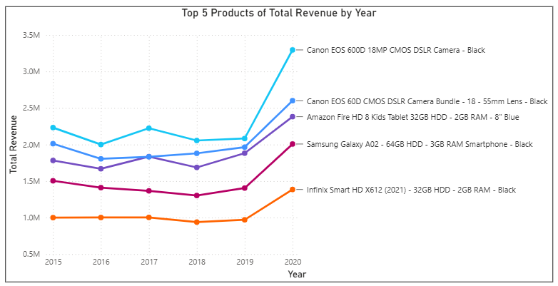
The above visual created by placing the line chart by allocating the year (order date’s) on X – axis and Total Revenue measure on Y – axis then placing the products in legend by filtering the product to top N = 5, where we can still observe that product performance from year 2015 to 2019 were in fluctuating and products named Samsung Galaxy AO2 & Infinix Smart HD are moving in decline pattern.
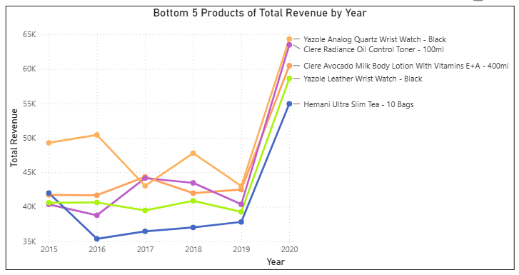
Similar to the Top performing products, here visual represent the Bottom performing products, where we can observe that 4 out of 5 products are showing the decline pattern from the year 2016 - 2017 to year 2019. Then from year 2019 to year 2020 shows steep increase in the growth of Revenue.

- While modelling the data relationships, what will be the type of relationship between the customer ID of Orders and customer tables?
Answer:
The relationship between CustomerID in Orders table and CustomerID in Customers table is One to Many.
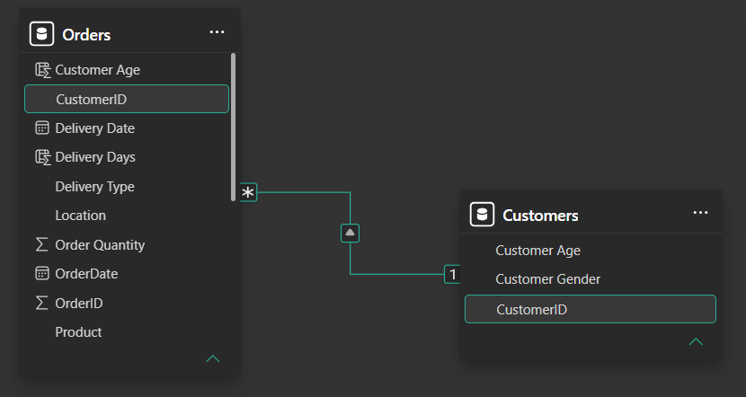
In Customers table the “1” (One) side, which indicates each CustomerID appears exactly once, similarly in Orders table the “*” (Many) side, which indicate CustomerID can appear many time as “One customer can order many orders” and the small “^” (to) relation between two tables. Which finally indicate One to Many (1 > *).

- How have you handled the null values in the data?
Answer:
Handling the NULL values place a vita role in managing the data for report making purpose, which need to present clean and reliable.
- Once after Importing the E-Commerce Dataset to Power BI, I can observe that there are nearly 5 empty Columns named Column 18 to Column 22 which I removed / Deleted from the model.
- Similarly to Columns there is presence of 199 empty rows, which could cause the problem during the slicer creation in dashboard, so I removed those rows by “Remove Empty Rows”.
- Then there are 8 missing values for the unit price and quantity where the sale price is showing the price of shipping price, which even not possible to do reverse calculations, keeping those rows values could effect the Total Revenue calculations and other calculations, so to avoid those trouble I removed those 8 rows which is nearly 0.007% of the existing dataset.
- Coming to the Reason Attribute (Column) there is clear visibility that it only applicable to the Returned Status, while for the Delivered status it’s not applied, so to overcome this I have added the custom column named “Reason” using the Custom Column Formula I handled those NULL values.
Custom Column Formula:
= if [Status] = "Delivered" and [Reason] = "" then "Not Applicable"
else if [Status] = "Returned" and [Reason] = "" then "No Reason"
else [Reason]

- Were there any data format issues in the data, and if there were/are how you would handle them?
Answer:
Here in the provided dataset has no issue related to the data format. If there were any issues related to data format I would resolve as mentioned below,
- Firstly I would have identify the Numerical values present in the text format, where I resolve this by moving to table view and selecting the column which data format need to be a numerical value but present in text format. I would have change the format to whole number or decimal number.
- Then look for the date related columns present in the dataset and check for them does values exists in proper date format or not. If not again moving to table view and change the format to date.
- Then check for the text or categorical value columns to identify if there any trailing space are present, if present I would have use the TRAIL function to remove the extra spaces.
- Then concentrating on the columns containing values like Boolean values – True or False. I would correct if there any miss leading values are present.

- When we add a column in Power Query what’s the code that comes in M language in the formula bar? What do you know about M-query?
Answer:
After clicking the Add Column by selecting the Custom Column in Power Query and need to type a formula, Power BI wraps it into a step using the Table.AddColumn function.
As for creating the Reason (cleaned) table, it shows as
= Table.AddColumn(
#”Renamed Columns”,
“Reason (Cleaned)”,
each if [Status] = “Delivered” and [Reason] = “” then “Not Applicable”
else if [Status] = “Returned” and [Reason] = “” then “No Return Reason”
else [Reason]
)

M Query: M is a functional programming language that powers Power Query, by every single click in Power Query Editor UI is actually just Power BI writing M code behind the scenes and adding it as new Applied Step.
Some common key things to be known are,
- It’s functional, not procedural
- Case sensitive
- It’s full expression language, not just a query tool

- Identify the top 5 most valuable customers using a composite score that combines three key metrics: (SQL)
  - Total Revenue (50% weight): The total amount of money spent by the customer.
  - Order Frequency (30% weight): The number of orders placed by the customer, indicating their loyalty and engagement.
  - Average Order Value (20% weight): The average value of each order placed by the customer, reflecting the typical transaction size.
Answer:
For calculating the composite score in SQL, initially loaded a data to MySQL then checked for the data proficiency.
Then writing the Query to extract the top 5 most valuable customer using composite score by using the aggregation function as SUM() for calculating the Total Revenue, COUNT() for Order Frequency and AVG() for Average Order Value, then for calculation of composite score multiplied and summed on the given criteria and named the column as composite score. Grouping the CustomerID to result the aggregated values.
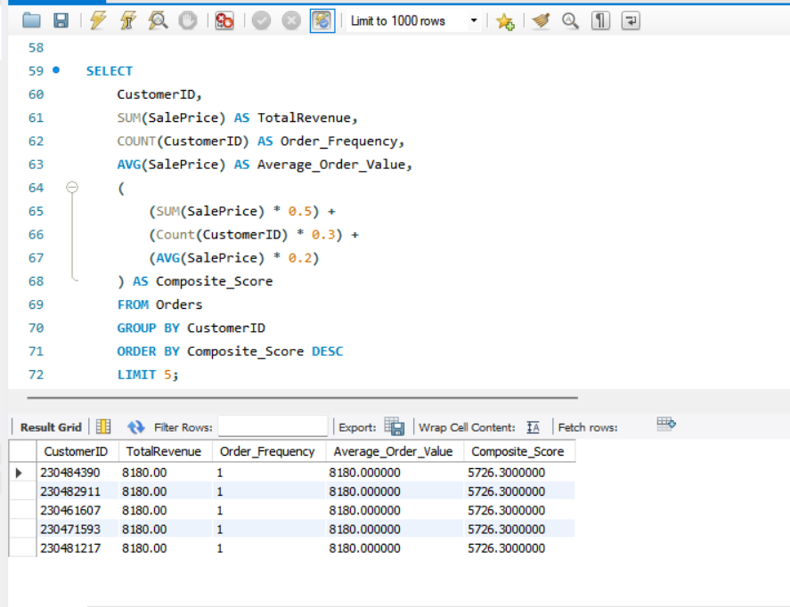

- Calculate the month-over-month growth rate in total revenue across the entire dataset. (SQL)
Answer:
For calculating the Month Over Month growth rate in Total Revenue, by using the LAG() window function for extraction of previous month’s revenue for calculating the month over month growth rate.
Initially starting with the CTE (Common Table Expression) named Monthly Revenue by formatting the Order Date column to year – month date format the aggregating the Sale Price by the SUM() function.
Continuing with next CTE named Previous Month by taking the columns from the Monthly Revenue CTE adding the LAG() window function to extract previous month’s Revenue.
At finally showing the result table as Order Month, Total Revenue, Previous Month Revenue, Month Over Month Growth Percent rounding to 2 decimal places which written in given below Query.
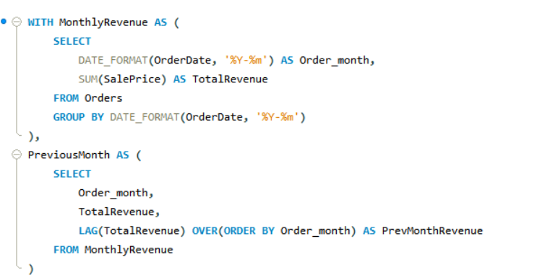
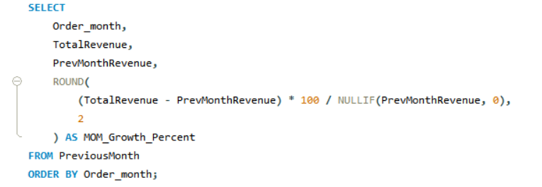
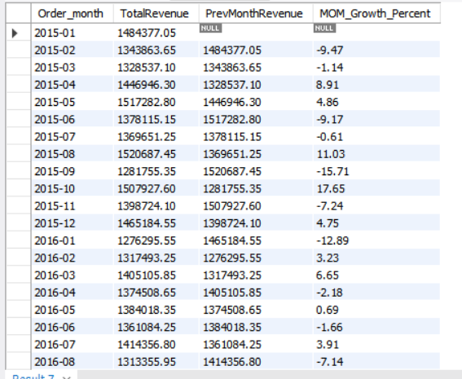
The above table visuals the result of the Query by showing the Month Over Month growth rate in the Total Revenue.

- Calculate the rolling 3-month average revenue for each product category. (SQL)
Answer:
For calculation of the Rolling 3 Month Average Revenue by using the Windows functions along with aggregation of AVG() function.
Solved by writing a Query In SQL using the CTE (Common Table Expressions) named the Category Revenue which extracts the Product Category, Year Month date format along with the Monthly Revenue using the SUM() aggregation function.
Then showing the result table by writing query to extract the Product Category, Order Month, Monthly Revenue and the Rolling Average using the windows function integration the “ROWS BETWEEN PRECEDING AND CURRENT ROW” rule.
Where the PRECEDING helps to concentrate how many rows need to be concentrated and CURRENT ROW indicate the present row where the process is being handling.
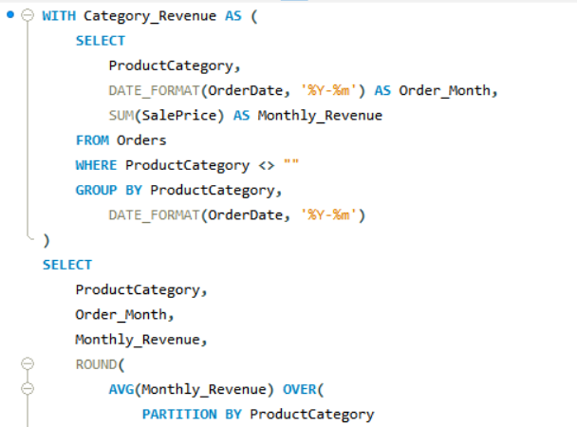
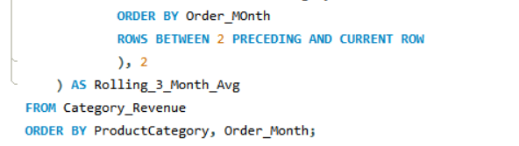
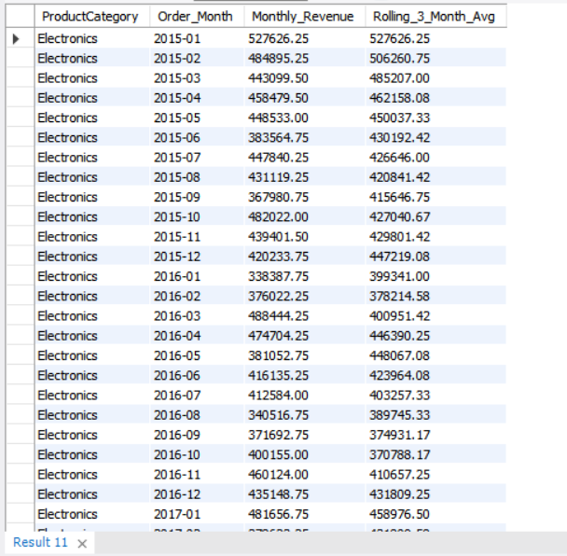
Here the above table shows the out put of query by listing the each Product Category along with Year Month order showing each months revenue and rolling 3 month average of the Revenue.

- Update the orders table to apply a 15% discount on the `Sale Price` for orders placed by customers who have made at least 10 orders. (SQL)
Answer:
For Updating the table Orders to apply 15% discount on Sale Price for customer who placed at least 10 orders.
Writing the Query of UPDATE orders table by joining a FC (Frequent Customers) table to check for condition count of orders more than 10.
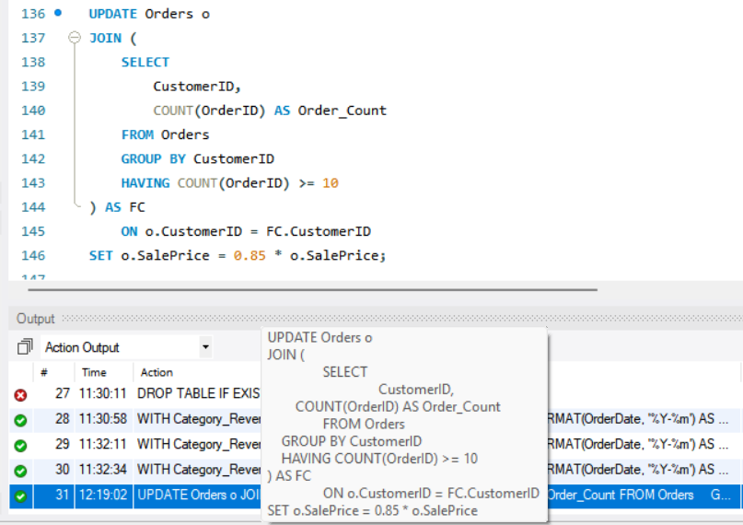

- Calculate the average number of days between consecutive orders for customers who have placed at least five orders. (SQL)
Answer:
For calculating the Average Number of days I have used the Windows function LAG() to fetch the Previous order date and used the aggregation function COUNT() to get number of orders more than or equal to 5.
Query contains the CTE (Common Table Expression) named Order Gap, which extracts the Customer ID, Order ID, Order Date and LAG() function to fetch the previous Date of Order, then CTE named Customer Count for checking the condition of the at least 5 orders.
Then resulting table query extract the Customer ID and Average number of days performed by AVG() aggregation function between the Order Date and Previous Order Date, making condition in where Previous Order Date is not to be NULL.
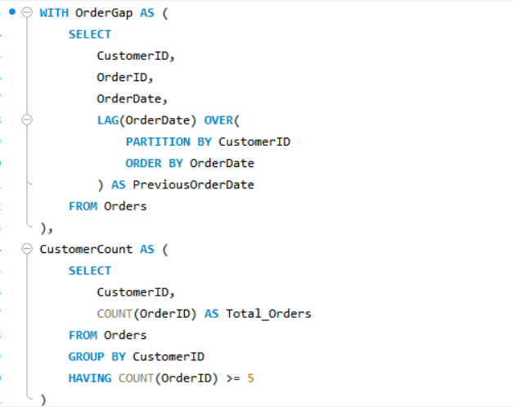
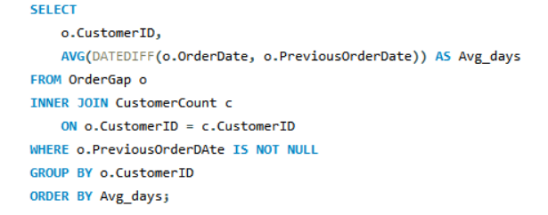
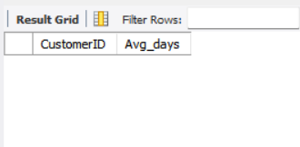
The above table no Values because of there is no customer present how placed orders more than or equal to 5.

- Identify customers who have generated revenue that is more than 30% higher than the average revenue per customer. (SQL)
Answer:
For finding the customers who generated revenue more than 30% of overall average revenue by using the CTE’s (Common Table Expression).
Quey as CTE named Customer Revenue help to extract the each customer total revenue by using the SUM( ) Aggregation function, then CTE named Avg Revenue extract the overall average revenue per customers.
Selecting the Customer ID, Total Revenue, Avg Revenue and Percentage above the revenue for showing the final executing table result.
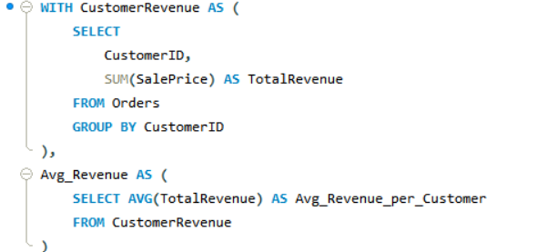
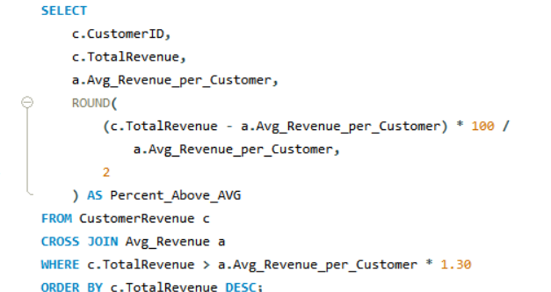
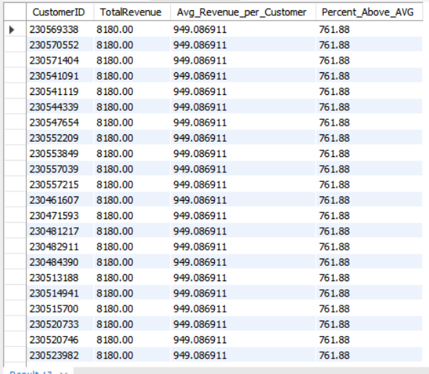
The above table results the Customers who’s revenue is more than the overall average of the Revenue.

- Determine the top 3 product categories that have shown the highest increase in sales over the past year compared to the previous year. (SQL)
Answer:
To find the top 3 product category whose increase in sales over past year (2020) compared to previous year (2019), by using the CTE’s (Common Table Expressions).
CTE named Yearly Revenue extracts the Product Category, Order Year, Total Revenue aggregated by SUM() function, then CTE named Revenue extracts the Product Category, Year 2020 Revenue and Year 2019 Revenue.
Then final result table showing the Product Category, Year 2020 and 2019 Revenue, there increase in Revenue and Finally their Growth Percentage and final result is limited to top 3 by ordering the increased revenue in descending.
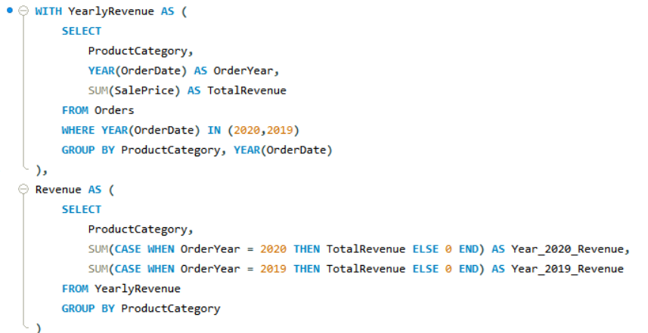
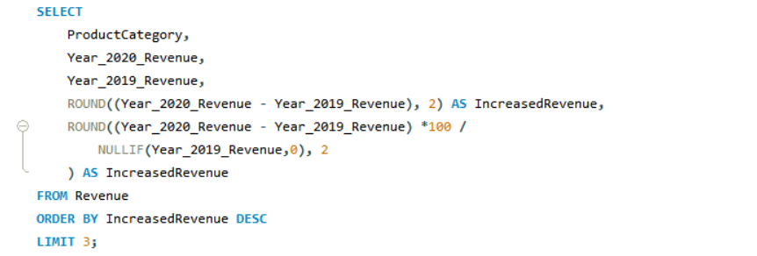
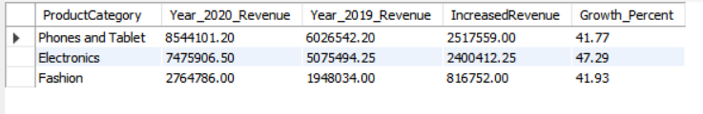
The above out put table shows the top 3 product categories which have increased in sales over past year.

Subjective Questions
- Explain the revenue breakdown by year and by-product. Evaluate how different products contribute to annual revenue and come up with suggestions to increase the sales of the low-selling items.
Answer:
Approach:
  - Aggregated Sale Price (Total Revenue) by Year for Overall Revenue trend by Area chart. Revenue holds flat in the 16 to17M band from year 2015 to 2019, then jumps to nearly 24M in year 2020, a 43% single year increase, matching the customer count surge.
  - Table visual shows the top 5 Products contributing to Total revenue from Year 2015 to 2020 along with their corresponding Category. Breaks revenue down at the finest grain showing the top 5 products across different years. This indicate it's the same 5 products performing consistently, every single year.
  - Clustered Bar refers to the Bottom 10 product performance in the total revenue. These 10 products sit in the 0.24M to 0.51M range per product, dwarfed by the top performers below.
Charts / Visuals:
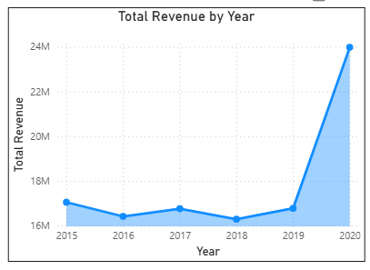
Total Revenue by Year (Area Chart)
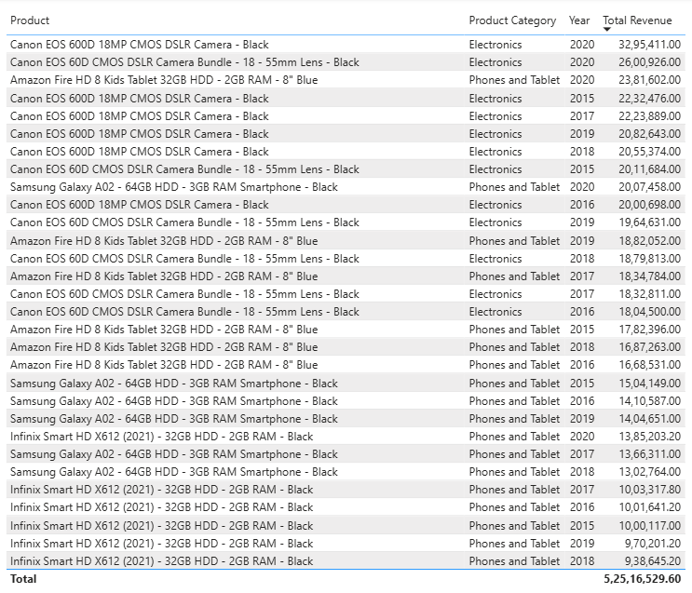
Top 5 Total Revenue of Products & their Category along with Year (Table)

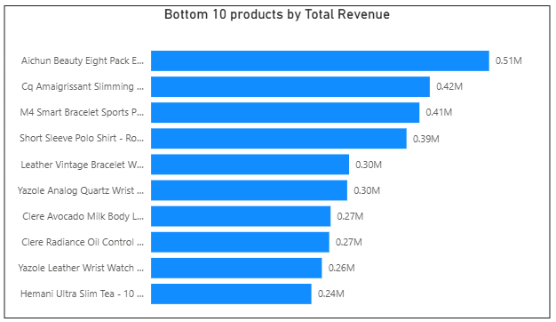
Bottom 10 Products by Total Revenue (Clustered Bar Chart)
Insights:
- Revenue remained flat between 2015 and 2019, holding in the 16 to 17 million range each year, before rising sharply to approximately 24 million in 2020, a jump of roughly 43 percent in a single year.
- The top of the product revenue table is dominated by just five products, repeating across every year from 2015 to 2020,
  - Canon EOS 600D 18MP CMOS DSLR Camera
  - Canon EOS 60D CMOS DSLR Camera Bundle
  - Amazon Fire HD 8 Kids Tablet
  - Samsung Galaxy A02 Smartphone
  - Infinix Smart HD X612
These are not five different high performers appearing once each; they are the same five products delivering strong results consistently, year after year.
- The 2020 revenue increase amplified the performance of these existing top five products rather than introducing new winners. Each of the five products recorded its highest or near-highest single year revenue figure in 2020, while the overall ranking of top products remained unchanged from prior years.
- Bottom Ten products, primarily from Health and Beauty and Fashion categories, generated only about 3 percent of total revenue combined, indicating that underperformance in the catalogue is concentrated in specific categories rather than spread evenly across all products.
Recommendations:
- Prioritize the inventory availability, marketing spend, and supplier relationships for the five core products identified above, since they are proven, repeat, high-value performers across every year in the dataset.
- Introduce one or two additional products within the same subcategories as the top five, specifically Electronics and Phones and Tablets, to reduce dependency on a small number of specific models.
- Bundle low-revenue products from Health and Beauty and Fashion with top-performing products as a gift-with-purchase or add-on, using the guaranteed customer traffic the core five products already generate rather than marketing weaker products independently.
- Design loyalty and Prime membership perks around purchases of the core five products, such as extended warranty coverage or priority express delivery, since customers purchasing these items already represent the highest-value transactions in the business.
- Reassess the bottom ten products for discontinuation or repositioning as bundled add-ons, since their combined six-year revenue does not match even a single strong year from one top-performing product, making continued independent investment in them a lower priority than the bundling strategy above.

- How many products were returned? Use a DAX function to get this metric. Examine the possible reasons for returns and consider how this metric could indicate improvements in product descriptions or quality control.
Answer:
Approach:
- Filtered Orders to Status = "Returned" and counted rows using a DAX CALCULATE + COUNTROWS pattern (below).
- Broke down the Reason column into its 5 categories to see which failure type dominates.
- Cross-tabulated returns against Product Category, both in raw count and as a return rate percent (returns / total orders per category), since raw count alone is misleading when categories have different order volumes.
- Identified the specific products with the highest return counts, to see whether returns cluster around particular items or spread evenly.
Charts / Visuals:
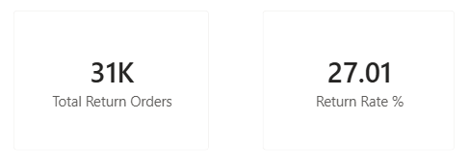
Card visuals showing the values of Total Return Orders & Return Rate %

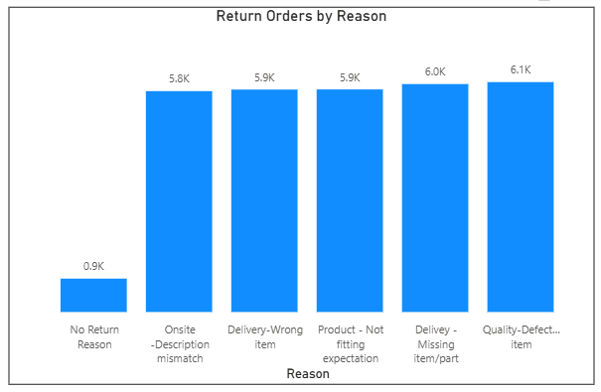
Clustered Column Chart showing the Number of returns based on the Return Reason
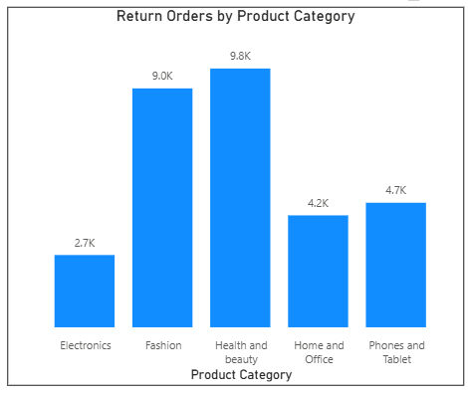
Clustered Column Chart showing the Return orders based on the Product Category
Insights:
  - The exact Total returned orders are 30,524 out of 112,992 which results Return Rate to 27.01%
  - More than 1 in 4 orders gets returned
  - Return rate is almost the same across all categories (26.2% to 27.5%), this is a company wide issue, not a category specific one
  - Health and Beauty (9.8K) and Fashion (9.0K) have the highest raw return counts, simply because they have the highest order volumes
  - Top return reasons, roughly equal in size:
    - Quality – Defective item: 6.1K
    - Delivery – Missing item/part: 6.0K
    - Onsite – Description mismatch: 5.9K
    - Delivery – Wrong item: 5.9K
    - Product – Not fitting expectation: 5.8K
- Exact 881 products returned with no reason recorded at all, a data gap worth fixing
  - Reasons fall into 2 groups:
    - Fulfilment errors (missing/wrong item): Nearly 39% of returns
    - Product/listing issues (defective, mismatch, not fitting): Nearly 58% of returns
Recommendations:
  - Fix fulfillment errors through better warehouse and packing checks
  - Fix product/listing issues through better descriptions, images, and size/shade guides
  - Add a pre-shipment quality control step to reduce defective item returns
  - Investigate and close the 881 no-reason-recorded returns
  - Apply fixes company-wide, not category-by-category, since the return rate is uniform across categories

- Whenever a customer goes to Amazon, they’ll filter the most rated products to buy the better category. Can you verify this using any visualization or table that the ratings of products impact their sales value?
Answer:
Approach:
- Aggregated Total Revenue grouped by Rating value 1-5 via donut chart along with it’s Total Revenue value & percent contribution.
- Calculated average Rating per Product Category using the line chart with shaded area.
- Broke down Rating by Product Category in a detailed table by each category to every ratings (1 to 5) along with their respected Revenue.
- Investigated why ratings 1 to 3 hold noticeably more revenue share than ratings 4 & 5, since this looked unusual, cross referenced Rating against Order Status.

Charts / Visuals:
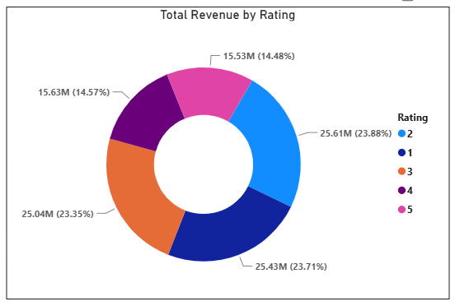
The Donut Chart shows Total Revenue Related to their Ratings along with percentage of their contribution.
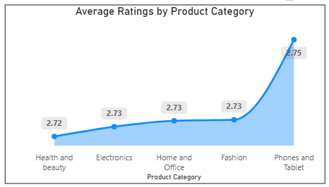
The above Area Chart shows the Average rating of each Product Category.
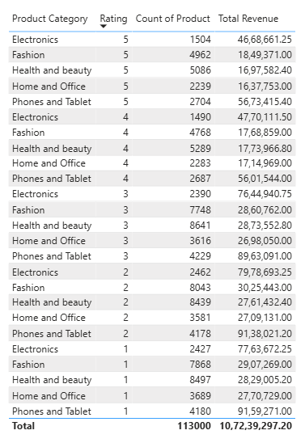
The above table says how Rating in each Product Category help in analysing the Total Revenue.
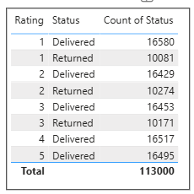
The above table clearly says how Order status impact by the Ratings.

Insights:
- Average rating is nearly identical across all 5 categories (2.72 to 2.75), this confirms that rating does not meaningfully differentiate any category, they're all clustered in a narrow band
- In the Total Revenue by Rating donut, ratings 1, 2, and 3 each hold roughly 23 to 24% of revenue, while ratings 4 and 5 each hold only nearly 14.5%, at first glance this looks like lower rated orders generate more revenue
- This is a structural/mechanical effect, not a real customer behaviour signal. Checking the raw rating distribution reveals:
  - Returned orders can only ever receive a Rating of 1, 2, or 3 and no returned order in the entire dataset has a rating of 4 or 5.
  - Delivered orders are spread almost evenly across all 5 ratings roughly 16,400 to 16,600 orders at each rating level.
  - This inflates the order count and therefore revenue in the low rating buckets, it's not that customers who leave low ratings are spending more, it's that the low-rating buckets contain an entire extra category of orders (returns) that the high-rating buckets are structurally excluded from
- Final conclusion is the Total Revenue by Rating chart is measuring the return rate's effect, not a rating-driven sales effect. This reinforces, rather than contradicts, our earlier finding that rating has no genuine influence on sales value.
Recommendations:
- Do not filter or promote products by rating alone, visuals show rating has no real effect on sales value in this dataset.
- Average rating barely moves across categories (2.72–2.75), so "most rated" isn't a meaningful way to distinguish "better" categories here.
- The revenue-by-rating split (23 to 24% for ratings 1, 2 and 3 vs nearly 14.5% for ratings 4 and 5) is caused by returns capping at rating 3, not by low-rated products actually selling more, don't read it as a sales signal.
- Continue driving purchase decisions using proven factors instead, category like Electronics, Phones, Tablet and the core 5 products already shown to reliably generate revenue.
- If Amazon-style "filter by top rated" is still a desired customer feature, first fix how ratings are collected, since the current field doesn't differentiate product quality enough to be useful for that filter.
- Revisit this analysis once ratings are decoupled from return status, to get a true read on whether rating genuinely drives sales.
- Investigate how revenue distribution varies across different locations. Explore which geographical areas contribute most to sales and consider the strategic implications for regional marketing and distribution efforts. How might location-based trends inform the company's market segmentation and resource allocation approach?
Answer:
Approach:
- Analysed total revenue at three levels of granularity by Zone (4 zones), Location (26 individual regions within Ghana), and Average Order Value by Location, to separate "how much revenue" from "how big is each typical transaction."
- Cross-referenced individual Location revenue against its parent Zone to identify whether a zone's performance is driven by one dominant location or spread across several contributors.
- Compared Total Revenue ranking against Average Order Value ranking per location, to distinguish high volume or low value locations from low volume or high value ones.

Charts / Visuals:
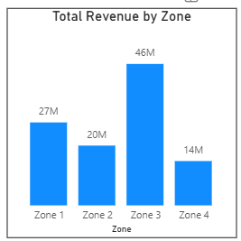
The above Stacked Column Chart represent the Total Revenue by each Zone’s.
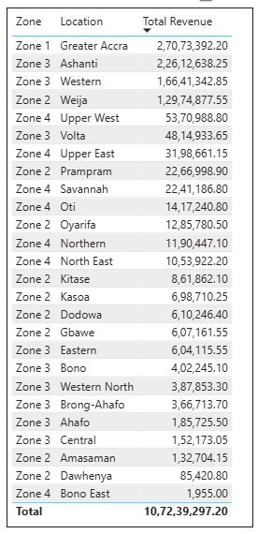
This Table says overall 26 locations (Zones) & their contribution in Total Revenue.
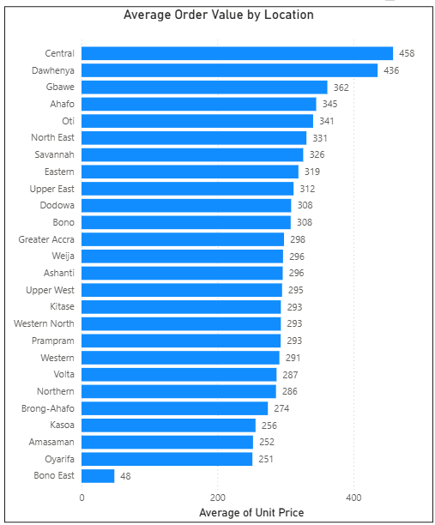
The above Stacked Bar Chart refers to the Average Value of Orders by Locations.
Insights:
- Zone 3 is the top-performing zone at 46M, but this is driven by breadth, not a single standout. It contains 9 locations with Ashanti (22.6M) and Western (16.6M) alone contributing over 85% of the zone's total.
- Greater Accra is the single most valuable location in the entire company, generating approximately 27M on its own, nearly 25% of total company revenue (107.2M) from just one location.
- Greater Accra is the only location in Zone 1, meaning one location single handedly outperforms the entire Zone 2 (nearly 19M) and Zone 4 (nearly 15M) totals combined against any other individual competitor.
- Revenue concentration and order value patterns diverge sharply, Central and Dawhenya post the highest Average Order Values (458 and 436), yet rank near the bottom for total revenue.
- Bono East is weak on every metric, not just volume, it has both the lowest total revenue (1,955) and the lowest Average Order Value (48), unlike Central or Dawhenya.
- Greater Accra, despite dominating total revenue, sits mid pack on Average Order Value (298), its revenue leadership comes from high order volume, not large basket sizes, mirroring the volume vs value split seen earlier in the product category analysis.
Recommendations:
- Treat Greater Accra as the company's flagship market, prioritize inventory, delivery infrastructure and marketing spend here first, since it single handedly represents roughly a quarter of total revenue.
- Within Zone 3, focus resource allocation on Ashanti and Western specifically rather than treating the zone as uniformly strong, the other 7 locations in that zone contribute comparatively little.
- Target Central and Dawhenya with volume driving campaigns rather than value driving ones, since their high Average Order Value shows customers there already spend generously per transaction.
- Use the Zone level view for high level resource planning as regional warehouse placement, but always validate decisions against the Location level breakdown.
- Consider a 2 tier regional strategy,
  - A small number of high volume flagship locations (Greater Accra, Ashanti, Western) optimized for speed and availability.
  - A long tail of low volume locations better served through a lighter touch, cost-efficient fulfillment model rather than equal investment across all 26 locations.

- Determine which month could benefit from enhanced promotional offers to boost sales. Can you suggest some targeted marketing strategies here?
Answer:
Approach:
- Reviewed Total Revenue by Month, Orders by Month, and Category-by-Month tables shared.
- Cross-checked the monthly pattern against 2015–2019 alone (excluding 2020) to confirm whether the dip after May is a genuine recurring pattern or a 2020-specific event.

Charts / Visuals:
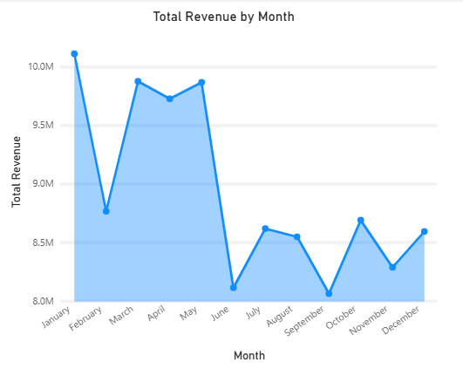
The above Line cum Area Chart represent the Total Revenue by Month, by aggregating across all years.
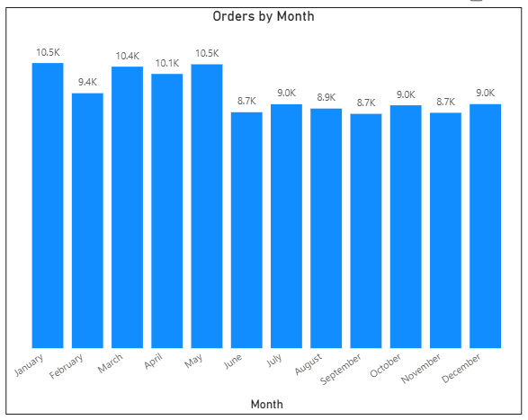
The above Clustered Column Chart represent the Number of Orders placed by Month, aggregating the Years.
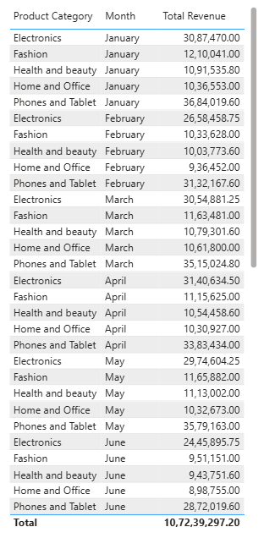
The above table refers the Product Category Performance by Month for Revenue, aggregating Years.
Insights:
- The Area chart shows revenue high Jan to May (nearly 9.7M to 10.1M) and low Jun to Dec (nearly 8.0M to 8.7M), which looks like a strong seasonal pattern at first glance.
- Splitting the data by year reveals this is mostly a 2020 artifact, in 2020 the revenue crashes from 2.9M/month (Jan to May) to 1.3 to 1.5M/month (Jun to Dec), this is the June 2020 anomaly we identified earlier, not a real yearly cycle.
- Excluding 2020, actual 2015–2019 monthly revenue is fairly flat (6.3M to7.2M range), with no dramatic mid year collapse, the "June crash" doesn't recur in normal years.
- Within the genuine 2015 to 2019 pattern, February is the consistently weakest month (6.31M, the lowest of all 12), followed by September (6.68M) as the second-weakest.
- Orders by Month confirms February and September also have below average order counts (9.4K and 8.7K respectively), the weakness is in volume, not just order size.
- Category breakdown (Jan to June) shows Phones and Tablet and Electronics dominate every month proportionally the same way, the February/September dip isn't isolated to one category, it's broad-based.

Recommendations:
- Target February as the primary month for enhanced promotions, it's the most consistently underperforming month once the 2020 anomaly is excluded.
- Run a secondary, lighter promotional push in September, the next weakest recurring month.
- Pair February promotions with the core 5 high-performing products (Canon, Samsung, Amazon Fire, Infinix) to maximize campaign ROI, since these already reliably convert.
- Track next year's February/September performance post campaign to confirm whether the promotional push meaningfully closes the gap versus the stronger months.

- Identify which products may require increased marketing efforts. Which items have high prices yet underperform in sales?
Answer:
Approach:
- Reviewed the Unit Price vs Total Revenue scatter, the Top 10 Unit Price bar chart, and the detailed price / order count / revenue table.
- Investigated the one point in the scatter plot that breaks the otherwise clean price to revenue trend, by pulling its average order quantity per transaction.
- Compared order counts across the two highest priced products to rule out "fewer customers" as the cause of the revenue gap, since order volume is known to be near-uniform across the catalogue.
- Calculated average units per order for both products directly from the Orders table, isolating basket size as the specific driver behind the mismatch between price rank and revenue rank.

Charts / Visuals:

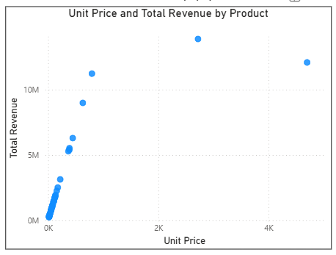
The Scatter plot refers to the Unit Price and Total Revenue of the Product.
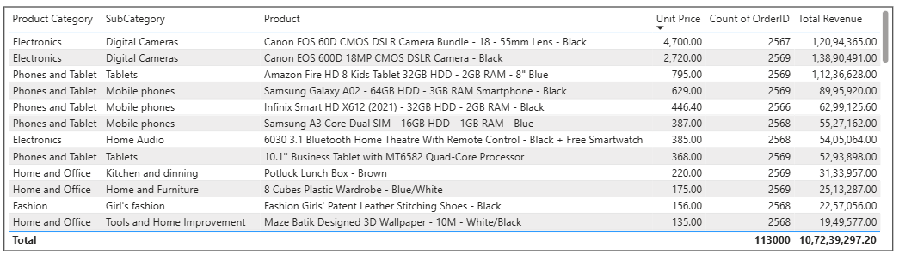
The above table shows the Products with highest Unit Price with their Order count and Total Revenue.

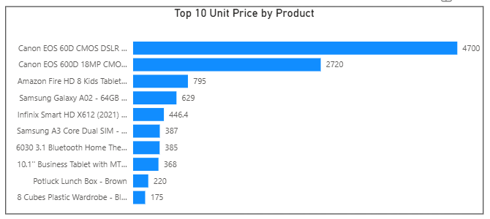
The above Clustered Bar chart plots the result of table maintained by top 10 products.
Insights:
- The scatter chart shows a broadly linear relationship, higher unit price generally means higher revenue.
- Canon EOS 60D CMOS DSLR Camera Bundle (4,700, the single most expensive product you sell) generates 12.09M in revenue while the Canon EOS 600D (2,720, priced 42% lower) generates 13.89M, nearly 1.8M more, despite its lower price.
- Order counts for both products are almost identical as 2,567 to 2,569 consistent with the earlier finding that every product gets a near uniform nearly 2,568 orders, so the revenue gap isn't about the Bundle attracting fewer customers.
- The real cause is basket size, the EOS 600D averages 1.98 units per order, while the EOS 60D Bundle averages exactly 1.00 unit per order, customers are buying roughly double the quantity of the cheaper camera, but never buying more than one Bundle at a time.
- This makes the EOS 60D Bundle the clearest "high price, underperforming" product in the catalogue.
- No other high price product in the Top 10 shows this same disconnect Amazon Fire HD 8 (795), Samsung Galaxy A02 (629), and the rest all rank in revenue roughly where their price would predict.

Recommendations:
- Prioritize marketing effort specifically on the Canon EOS 60D Bundle, it's the one high value product genuinely leaving revenue on the table relative to its price point.
- Test bundling incentives that encourage multi-unit purchases as "buy 2, get accessory free" since its core weakness is single unit only orders, not lack of customer interest.
- Investigate whether the Bundle's higher price itself is suppressing multi-unit orders, a customer may buy one DSLR bundle for personal use but rarely buy two, unlike a base camera body that might be gifted or resold.
- Position the Canon EOS 600D as the marketing anchor instead, since it already proves that this price tier (nearly 2,500 to 2,700) supports multi-unit purchasing behaviour, the Bundle could be marketed as an upsell path from the 600D rather than as a standalone flagship.
- Monitor future high price product launches for the same single unit pattern early, using average order quantity as a leading indicator of underperformance.

- Assess which products should have discounts. How can targeted incentives drive sales and customer loyalty for specific products?
Answer:
Approach:
- Reviewed the Bottom 10 Products by Total Revenue, and the products with the lowest Average Order Quantity, both cross-referenced against Return Rate.
- Split candidates into two distinct groups based on why they underperform, low basket size vs genuinely low demand, since each requires a different discount strategy.
- Checked each candidate's return rate against the company average (27.01%) to flag where a discount could backfire rather than help.

Charts / Visuals:
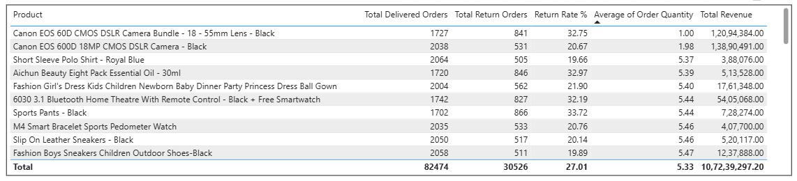
The above table gives the overall performance of the Products, as Number of Delivered and Returned Orders, each products return percentage and Average Order Quantity along with their contribution to Total Revenue.

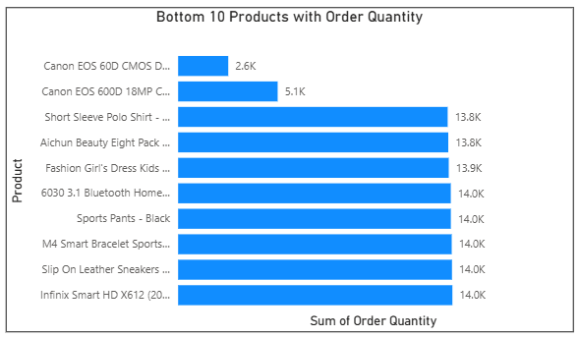
The above Stacked Bar chart represents the 10 Products with Less Quantity sold.
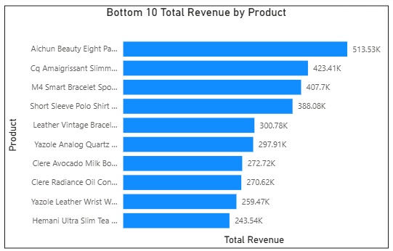
The above Clustered Bar Chart represent the Products underperforming in Total Revenue generation.
Insights:
- Group 1: High value, single unit only products,
  - The Canon EOS 60D Bundle (4,700, AOQ 1.00)
  - Canon EOS 600D (2,720, AOQ 1.98)
High-revenue products capped by basket size, not by low demand. A quantity based discount ("buy 2, save 10%") is the right lever here, since these products don't lack customers, they lack multi unit orders.
- Group 2: Genuinely low revenue, low-price long tail products, The Bottom 10 by revenue all sit in a narrow, unremarkable order quantity band of 5.37 to 5.60 their problem isn't basket size, it's simply low unit price * modest volume.
- A critical split within Group 2, return rate diverges sharply even among similarly low revenue products,
  - Low return subgroup (safe to discount): All comes below the 27.01% company average.
    - Hemani Slim Tea (20.71%)
    - Yazole Leather Watch (20.52%)
    - Clere Toner (21.33%)
    - Short Sleeve Polo (19.67%)
    - M4 Bracelet (20.76%)
    - Cq Slimming Tea (21.58%)
  - High return subgroup (discounting is risky): All were well above average, some approaching 34%.
    - Clere Avocado Milk Lotion (33.32%)
    - Yazole Quartz Watch (33.76%)
    - Leather Vintage Bracelet (32.58%)
    - Aichun Beauty Oil (32.97%)
- The Canon 60D Bundle itself has a high 32.76% return rate, higher even than several Fashion items.
- The pattern across both charts confirms discounting alone isn't the universal fix, for the high return subgroup, low sales likely stem from fit/quality/description issues.

Recommendations:
- Apply a quantity based discount as 10% off for 2nd unit to the Canon EOS 600D specifically, its low 20.67% return rate makes it safe to push toward larger baskets.
- Hold off on a quantity discount for the Canon EOS 60D Bundle until its 32.76% return rate is addressed separately, discounting it now risks amplifying returns rather than revenue.
- Apply straightforward price discounts to the low return Group 2 products, these are safe, low-risk candidates where reduced price is likely to convert directly into more completed sales.
- Do not discount the high return subgroup, until their underlying return reasons are fixed. For these, prioritize the product description and quality control recommendations from the earlier returns analysis.
- Use loyalty linked incentives as "get this add-on free after your 3rd order" for the low return, low price long tail, this both moves inventory and reinforces repeat purchase behaviour.
- Track return rate alongside revenue for every future discount campaign, this analysis shows that revenue rank alone would have missed the fact that half these "obvious" discount candidates are actually return-risk products in disguise.

- Come up with a loyalty program to benefit the company’s customers. From the available lot of customers come up with strategies to bucket them and provide benefits under different loyalty programs.
Answer:
Approach:
- Reviewed the Revenue Bucket histogram to confirm the shape of customer spend distribution.
- Reviewed Total Revenue by Age Group to identify which customer segments contribute most.
- Reviewed Total Revenue by Customer Gender to check for a meaningful demographic skew.
- Combined all three views to design loyalty tiers that are both spend-based (from the histogram) and demographically informed (from Age/Gender), so marketing messaging for each tier can be tailored, not just the discount amount.

Charts / Visuals:
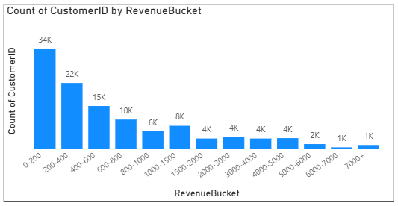
This Clustered Column chart show the Number of Customers in the particular Revenue segment (Revenue Bucket).
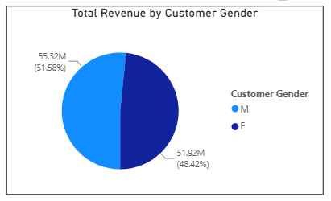
This Pie chart represent How the Customer Gender plays role in Total Revenue.
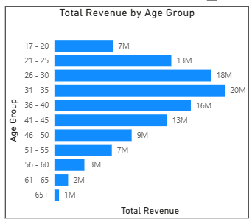
This Clustered Bar chart represent the Age Group contribution to Total Revenue.

Insights:
- Revenue distribution is heavily skewed, most customers spend under 200, very few reach 7,000+.
- Ages group of 26 to 45 drive nearly 62% of total revenue, with in that 31 to 35 age group as the single strongest bracket.
- Revenue drops sharply outside the 26 to 45 age group, under 20 and over 55 combined contribute less than the 31 to 35 group alone.
- Gender split is nearly even as 51.6% Male and 48.4% Female, not significant enough to base tiers on.
- High spenders are likely concentrated in the 26 to 45 age band, so top tier messaging should target that group specifically.
Recommendations:
Proposed Loyalty Structure, spend based tiers, informed by age skew,
- Platinum for the top 10% by spend: Free Express delivery upgrade on every order, early access to new product launches, and a dedicated support line.
- Target messaging toward the 26 to 45 age band's likely channels (mobile app, targeted digital ads), since this age group drives the most revenue and is the highest value segment to retain.
- Gold for the next 20% by spend: Percentage based cashback or store credit on every purchase, plus quarterly bonus discount vouchers, a strong incentive tier to convert into Platinum.
- Silver for the next 30% by spend: Occasional targeted discount codes and birthday or anniversary offers, designed to increase purchase frequency and spend rather than reward already high spend.
- Bronze for the bottom 40% by spend: Entry-level perks such as free shipping thresholds as free delivery over 500, low cost incentives aimed at nudging this large but low spending group toward their next purchase, rather than expensive rewards this segment hasn't earned yet.

- Using the DAX functions Calculate and a row iteration DAX function calculate the total sales for the Product Category “Fashion” and delivery type “Shipped from Abroad”. What are the other types of DAX functions you have used in the project?
Answer:
Approach:
- Built a measure combining CALCULATE (to apply two filters) with SUMX (a row-iteration function) to sum Sale Price for orders matching both conditions.
- Filtered on Product Category = "Fashion" and Delivery Type = "Shipped from Abroad" simultaneously.
- Displayed the result on a Card visual for a clear, single-number readout.

Charts / Visuals:
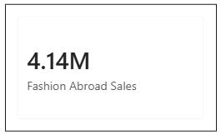
The card visuals represent result of the Fashion Category for the Abroad Sales delivery type.
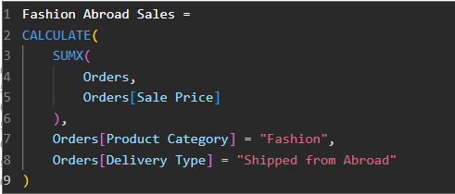
The above visual represent the DAX Formula used for the creation of measure “Fashion Abroad Sales”.
Insights:
- Fashion products shipped from abroad generated ₹4.14M in total sales, confirmed against an independent calculation, so the measure is working correctly.
- Recall from the delivery-time analysis: "Shipped from Abroad" averages 14.99 days, nearly triple Express's 3.49 days, so a large share of Fashion revenue is tied to your slowest fulfillment option.

Recommendations:
- Investigate whether faster shipping options (Express/Standard) are actually available for these Fashion items, or whether "Shipped from Abroad" is the only option for a chunk of the Fashion catalogue, if it's the only option, that's a supply chain gap worth closing.

- Wait Times Correlated with Demographics and Care: Explore how average wait times vary across different product categories to optimize scheduling and staffing.
Answer:
Approach:
- Reviewed average delivery days broken down by Delivery Type, by Product Category, by the combination of both, and by Month, to isolate which factor actually drives wait time variation.
- Compared the magnitude of variation across each dimension as Category vs Delivery Type vs Month to identify where staffing or scheduling attention would have the most impact.
Charts / Visuals:
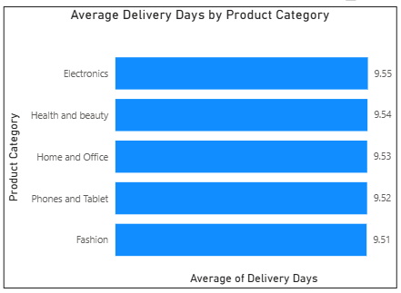
The above Clustered Bar Chart shows the Average Days taken to Deliver for Product Category.
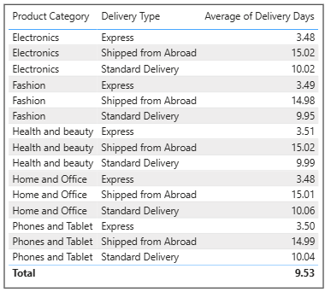
The above table visuals explain the Category with Delivery Type showing the Average Delivery Days respectively.
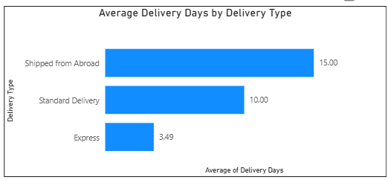
The above Clustered Bar Chart shows the Average Delivery days taken for each types of delivery mode.
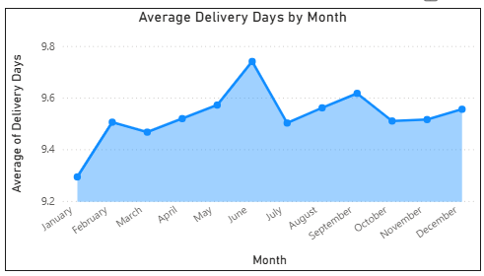
The above area chart shows the Average Delivery Days by Month, aggregating the Years.
Insights:
- Product Category has almost no effect on delivery time, average days range from just 9.51 (Fashion) to 9.55 (Electronics), a spread of only 0.04 days. Category is not a meaningful lever for optimizing wait times.
- Delivery Type drives nearly all the variation, Express in 3.49 days, Standard Delivery in 10.00 days and Shipped from Abroad in 15.00 days show a massive 11.5 day spread.
- The Category × Delivery Type table confirms this holds true everywhere, every single category shows nearly identical Express (nearly 3.48 to 3.51), Standard (nearly 9.95 10.06) and Abroad (nearly 14.98 to 15.02) times.
- Monthly wait times are fairly stable with one notable exception, January is the fastest month (9.30 days), while June spikes to the slowest (9.75 days), a difference of about half a day.
- Given Category contributes almost nothing to wait time variation, staffing and scheduling should be organized around Delivery Type capacity, not around product category teams.

Recommendations:
- Reallocate staffing or scheduling planning away from a category based model and toward a delivery-type-based model, Express, Standard, and Abroad each need distinct capacity planning, since that's where 99% of the variation lives.
- Investigate the Shipped from Abroad channel specifically for process improvement, since its 15 day average is the single largest driver of overall wait time across every category, even a modest reduction here would meaningfully lower the company-wide average.
- Monitor June and the broader May-June window for a recurring seasonal staffing gap, consider temporary capacity increases during this period to prevent the wait-time spike seen in the monthly trend.
- Since Category doesn't meaningfully affect wait time, there's no need for category specific delivery SLAs.
- A single, delivery-type-based SLA can apply uniformly across Electronics, Fashion, Health & Beauty, Home & Office, and Phones & Tablet.

- Explore if there is any relationship between the Delivery type and waiting time between ordering and receiving an item.
Answer:
Approach:
- Reviewed the Min, Max, and Average Delivery Days broken down by Delivery Type, alongside order counts, to confirm not just that averages differ, but that each delivery type occupies a genuinely distinct and consistent day-range.
- Checked for range overlap between delivery types to determine whether the relationship is a clean, reliable pattern or just a difference in averages with lots of hidden variation.

Charts / Visuals:
The above Clustered Bar Chart shows the Average Delivery days taken for each types of delivery mode.
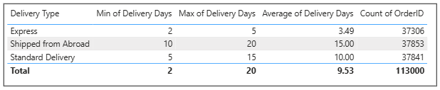
The above table shows the exact values related to Delivery Days with Number of Orders placed.
Insights:
- There is a clear, strong relationship between Delivery Type and wait time, each type occupies a distinct band: Express for 2 to 5 days, Standard Delivery for 5 to 15 days and Shipped from Abroad for 10 to 20 days.
- Express is both fastest and most consistent, a tight 3 day range (2 to 5 days) around its 3.49-day average, making it the most predictable and reliable option.
- Standard Delivery and Shipped from Abroad overlap in the 10 to 15 day range, meaning a slow Standard order (15 days) can take as long as a fast Abroad order (10 days).
- Order volume is almost evenly split across all three types (37,306 / 37,853 / 37,84, each roughly a third of all orders), so this isn't a case of one delivery type being a rare edge case.
- Shipped from Abroad has both the highest average and the widest absolute range (10 to 20 days, a 10 day spread) it's not just slow on average, it's also the least predictable of the three, which matters for customer expectation setting.

Recommendations:
- Set clear, delivery type specific expectations at checkout as "Express: 2 to 5 days," "Standard: 5 to 15 days," "Abroad: 10 to 20 days", so customers aren't surprised by the wider variability in Standard and Abroad options.
- Investigate why Standard Delivery's range is so wide (5 to15 days, a 10 day spread, a 3x difference between best and worst case suggests inconsistent fulfillment processes worth auditing.
- Since Express is both fast and consistent, use it as the anchor for premium or loyalty perks, its reliability, not just its speed, makes it a strong guarantee to offer Platinum or Gold tier customers.
- Prioritize process improvements for Shipped from Abroad given it has the highest floor (minimum 10 days), even reducing its best case scenario would meaningfully improve customer experience.
- Use this Delivery Type based structure as the basis for any future SLA commitments or staffing plans, since it's now confirmed twice as the dominant driver of wait time.

- Is there any relationship between shipping charges and product type?
Answer:
Approach:
- Reviewed Shipping Fee spread (Min/Max/Average) across all 5 product categories.
- Reviewed a scatter comparing Sum of Unit Price against Sum of Shipping Fee at the category level.

Charts / Visuals:
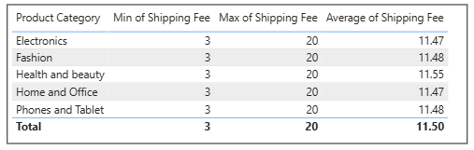
This above table shows the Product Category relation with Shipping Fee.
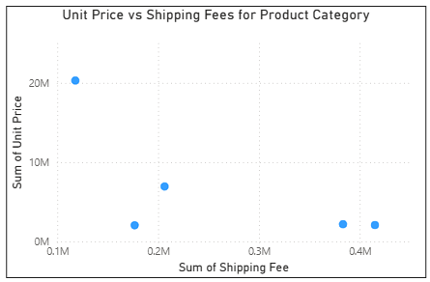
The above Scatter Chart shows the relation of Unit Price vs Shipping Fee for the Product Categories.
Insights:
- The table is the clearest evidence showing Shipping Fee is uniform across every product category. All 5 categories show the identical range for Min 3 & Max 20 and nearly identical averages of 11.47 to 11.55.
- This confirms there is no relationship between Shipping Fee and Product Category, shipping cost appears to be assigned independently of what's being shipped.
- Combined with the earlier check of correlation between Shipping Fee and Unit Price is to be -0.002, and Shipping Fee by Delivery Type also flat at nearly 11.5.
- The conclusion holds up from every angle: Shipping Fee is independent of product type, category, price, and delivery speed.

Recommendations:
- Report this as a confirmed negative finding, there is no relationship between shipping charges and product type in this dataset. This is a valid and useful conclusion, not an inconclusive result.
- If a scatter is included in the final report, use per order or per product points to avoid the composition bias seen in Image 2.
- Since Shipping Fee doesn't vary meaningfully by any factor examined (category, delivery type, price), treat it as a flat, largely fixed range cost in any pricing or promotional modelling.
- Worth flagging to the data owner: a shipping fee that's unrelated to product type, price, or delivery speed is somewhat unusual for a real e-commerce system, and may be worth validating against the actual business's shipping-fee policy to confirm this reflects genuine practice rather than a data generation artifact.

- Come up with strategies to decrease the low rating orders after analysing different factors like waiting time, shipping type, unit price, etc.
Answer:
Approach:
- Reviewed Average Rating split by Order Status (Delivered vs Returned), and Average Delivery Days and Average Unit Price broken down by Rating value.
- Compared the magnitude of variation across each factor to identify which ones genuinely drive rating differences.

Charts / Visuals:
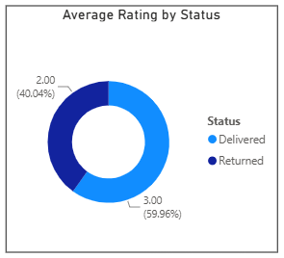
The above Pie chart shows how the Average Rating is effected by Status.
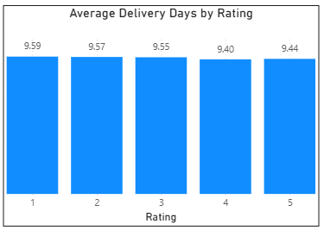
The above Clustered Column chart refers to the Average Delivery Days by Ratings.
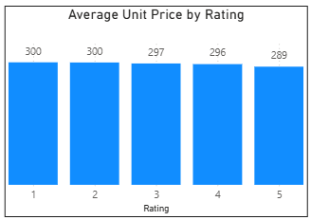
The above Clustered Column chart refers to the Average Unit Price by Ratings.

Insights:
- Order Status is the dominant driver of rating, and it's not close. Delivered orders average a 3.00 rating, Returned orders average 2.00, a full 1 point gap, and a status split of 59.96% (Delivered) vs 40.04% (Returned) in this donut, weighted by rating count rather than order count.
- Delivery Days shows only a very mild downward slope from 9.59 to 9.44 days from Rating 1 to Rating 5, a spread of just 0.15 days. This is far too small to be a meaningful driver; it's essentially flat with minor noise.
- Unit Price shows a similarly mild slope from 300 to 289 from Rating 1 to Rating 5, a spread of only 11, again negligible as a real driver of customer satisfaction.
- Neither wait time nor price meaningfully explains why an order gets a low rating, the real explanation is simpler and more structural:
  - A returned order cannot score above a 3, and a very large share of low ratings are simply returned orders being scored as returns, not delivered orders being scored poorly due to slow shipping or high price.

Recommendations:
- Redirect the rating improvement strategy away from delivery speed and pricing adjustments, neither shows a meaningful effect, so investment there won't move ratings.
- Focus rating improvement efforts on reducing the return rate itself, since returned orders are structurally capped at low ratings.
- Since delivery days and price only weakly correlate with rating, don't over-invest in "faster shipping" or "lower prices" as satisfaction levers, instead prioritize the quality control and description accuracy fixes already identified as the real problem behind returns.
- Reframe the internal narrative from "wait time and price drive dissatisfaction" to "returns drive dissatisfaction", this is a more actionable and accurate diagnosis, and should reshape.
- Track rating trends specifically among Delivered orders after implementing return reduction fixes, if the return rate drops, expect the overall average rating to rise simply because fewer orders fall into the low-scoring Returned bucket, even without any change to delivered-order satisfaction itself.

- Using the time intelligence DAX function, create a table to compare each month’s sales with the previous year’s same month’s total sales. So there will be four columns in the output year, month, total sales, previous_years_sales.
Answer:
To solve using the time intelligence DAX function named SAMEPERIODLASTYEAR().
Before using the function firstly we need the separate table delicate to the Date, so created a Date Table using the DAX formula,
DateTable =
CALENDAR(
MIN(Orders[OrderDate]),
MAX(Orders[OrderDate])
)
Then to avoid conflict created a new column for Year and Month separately, by DAX formula,
Year = YEAR(DateTable[Date])
Month = MONTH(DateTable[Date])
To better visibility of month name, I format the date column by DAX formula,
MonthName = FORMAT(DateTable[Date], “MMMM”)
Then for Previous Year Sales, Adding the new measure using the DAX formula, using the SAMEPERIODLASTYEAR() function.
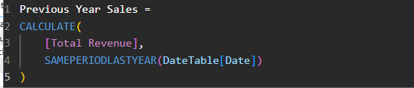
Here we used the CALCULATE() function to get the vale of Total Revenue in expression and placing the SAMEPERIODLASTYEAR() function in filter section, resulting the Previous year data for the current year in separate column.
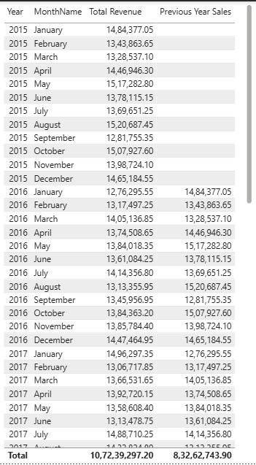
In above table we can see the Previous Year Sales empty for Year 2015 because there is no previous year data exists.
- What do you understand by PowerBI gateway? What are its use cases?
Answer:
Power BI Gateway:
- Power BI Gateway is a bridge or connector application that allows Power BI (cloud service) to securely connect and refresh data from data sources that are kept inside a private company network, like on-premises SQL Server, Excel files stored on a local server, or SAP systems.
- In simple words, Power BI reports are usually hosted on the cloud (Power BI Service), but company data is often stored inside internal servers that are not directly accessible from the internet for security reasons. The Gateway acts as a secure middleman between these two.
- It works by installing a small software application on a local machine or server within the company's network, which then handles the data transfer between on-premises data and the Power BI cloud service.
- Without a gateway, if the underlying data changes (say, new orders get added to a company's SQL Server), Power BI's cloud dashboard will not automatically update, because it cannot reach into the private network on its own.
Types of Power BI Gateway,
- Personal Gateway: meant for individual use, only the same user who set it up can use it to refresh their own reports. Good for small, single-person setups.
- Enterprise or Standard Gateway: meant for organization wide use, where multiple users and multiple data sources can be managed centrally by an IT admin, and multiple reports can be scheduled to refresh through it.
Use Case of Power BI Gateway:
- Scheduled Data Refresh: Automatically refreshing Power BI dashboards on a set schedule (say every morning at 6 AM) directly from an on-premises database, without needing anyone to manually export and re-upload files.
- Live Connections: Enabling real-time or near real-time Direct Query connections to on-premises data sources, so the report always shows the latest data without manual refresh.
- Secure Data Access: Allows companies to keep sensitive data inside their own network (behind firewall) while still letting Power BI's cloud service use that data for reports, which is important for industries like banking, healthcare, and government where data security is critical.
- Connecting Multiple Data Sources: A single gateway installation can be used to connect several different data sources at once (like SQL Server, Oracle, SAP, File shares), making it easier for IT teams to manage everything from one place.
- Power Automate and Power Apps Integration: The same gateway also supports other Microsoft Power Platform tools like Power Automate and Power Apps when they need to access on-premises data.
- Supporting Big Enterprise Reporting Needs: For big companies where the actual transactional data is huge and stored in internal servers (like this project's Orders and Customers tables, if they were hosted on a company SQL Server instead of a local Excel file), the Gateway would be the actual real-world method used to connect Power BI to that live data source.

- How would you approach this problem, if the objective and subjective questions weren't given?
Answer:
How I Would Approach This Problem in complete 10 steps as mentioned below,
Step 1: Understand the problem statement first
- Before touching any data, I would first read the problem statement 2-3 times and understand what exactly is being asked. Here, the ask is about customer rewards, discounts, Prime perks, and improving shopping experience.
- I would break this big goal into smaller, answerable parts myself, like: Who are our customers? What are they buying? Are they happy with what they bought? Is delivery fast enough? Which products/areas make the most money?
Step 2: Explore the raw data before doing anything else
- I would open the Excel file and just look around first — how many sheets, what columns are there, how many rows, what kind of values each column has (numbers, text, dates).
- I would not jump directly into charts. First I would check for missing values, duplicate rows, wrong data types, and any values that don't make sense (like negative prices or dates that don't match).
Step 3: Clean the data
- Based on whatever issues I find in Step 2, I would fix them one by one filling blanks where it makes sense, removing rows that are clearly broken, and fixing column data types (like making sure IDs are not being summed accidentally).
- I would keep this step separate from analysis, so my numbers later are trustworthy.
Step 4: Build the data model
- I would check how many tables there are and how they are related (like Orders and Customers connected through CustomerID), and set up proper relationships in Power BI so I can pull information across tables.
Step 5: Do basic exploration of data before answering the big question
- I would start with simple questions I ask myself: How many customers do we have? How many products? What's the total revenue? How is revenue spread by year, category, and location?
- This gives me a general feel of the business before trying to solve the harder "reward customers" problem.
Step 6: Look for patterns and problems in the data
- While exploring, I would keep noting anything unusual — like if returns are very high, if some products barely sell, if certain months are weak, or if ratings don't match what I expect.
- These small observations are usually where the real insights come from, not from a fixed question list.
Step 7: Connect findings back to the main problem statement
- Every pattern I find, I would ask myself: "How does this help with rewarding customers or improving their experience?" For example, if I find delivery is slow for one type of shipping, that becomes a possible loyalty perk (faster delivery for loyal customers). If I find some customers spend a lot more than others, that becomes the basis for a loyalty tier system.
Step 8: Build visuals only after I know what story I want to tell
- I would not just make random charts. I would first decide what point I am trying to prove, and then pick the chart that shows that point clearly (bar chart for comparison, line chart for trend over time, table for detailed numbers).
Step 9: Write final insights and recommendations
- After all the analysis, I would summarize what I found in simple points, and then suggest 2-3 practical, doable recommendations for each finding, directly connected back to the original goal of rewarding customers.
Step 10: Keep checking my own work
- At every step, I would double-check my numbers by calculating them in a different way (like I would cross-check a Power BI number with a quick manual calculation) just to make sure I am not presenting a wrong number in my final report.

Power BI Dashboard - Report

Main Tab:
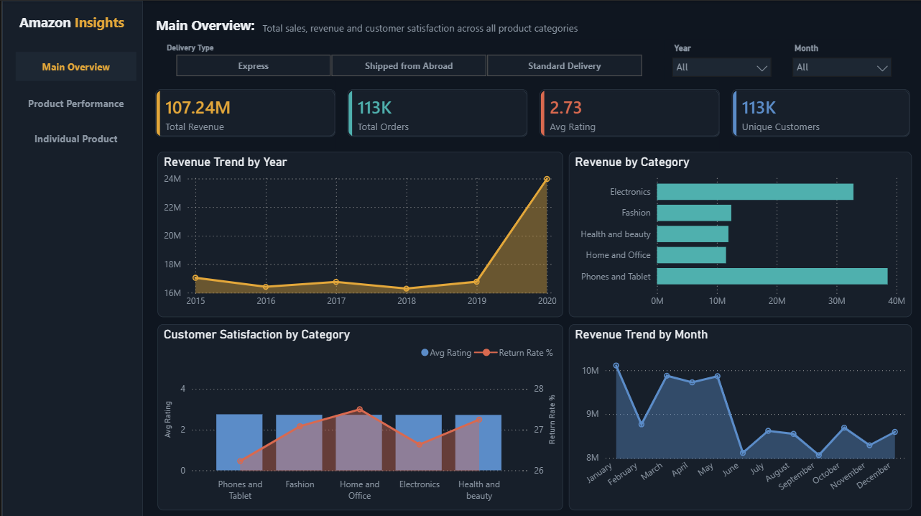

Product Tab:
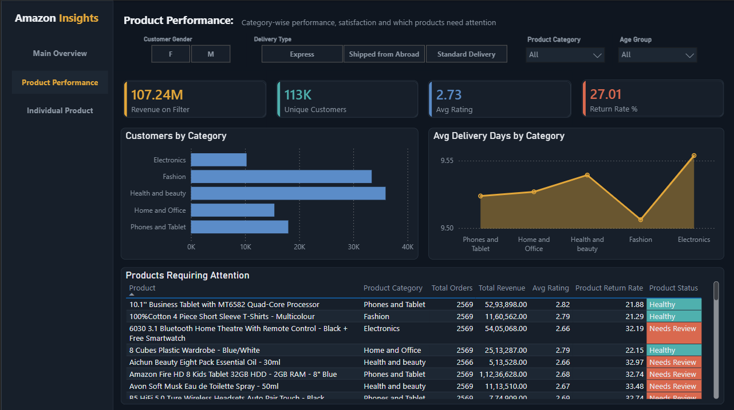
Individual Product Tab:
